***Summative Assessment***

***(Spring Boot, MySQL, Linux, Jenkins, Docker, NodeJS)***

**Problem Statement -1:**

* This project is a demo to build a sample Employee Registration module using Java (Springboot, ORM), MySQL and Linux.

***Code is attached in Folder named Problem Statement-1***

**Tools and Technologies Used:**

* IDE - Eclipse
* JDK - 11
* Apache tomcat - 9
* JSTL - 1.2.1
* Servlet API - 2.5
* MySQL Workbench

**Project Structure**

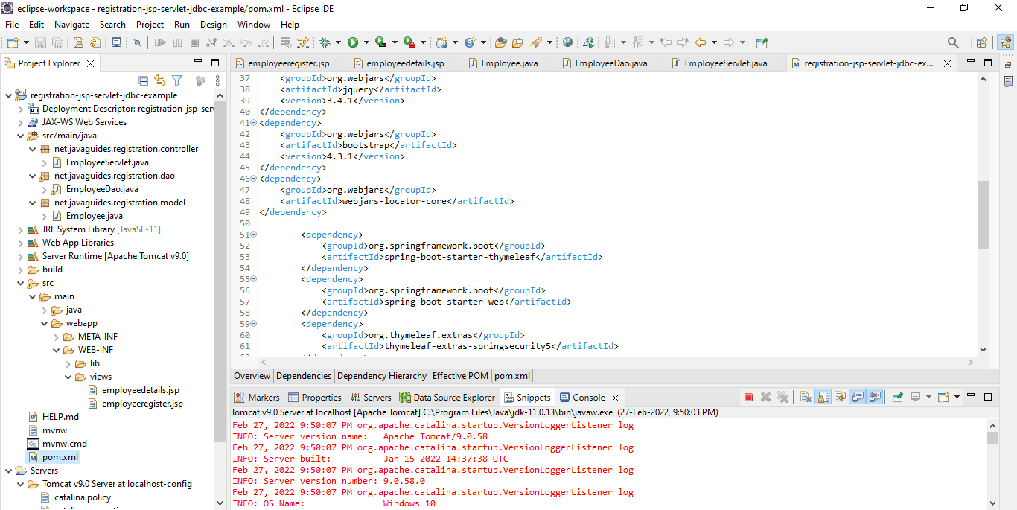

**Registration Form**

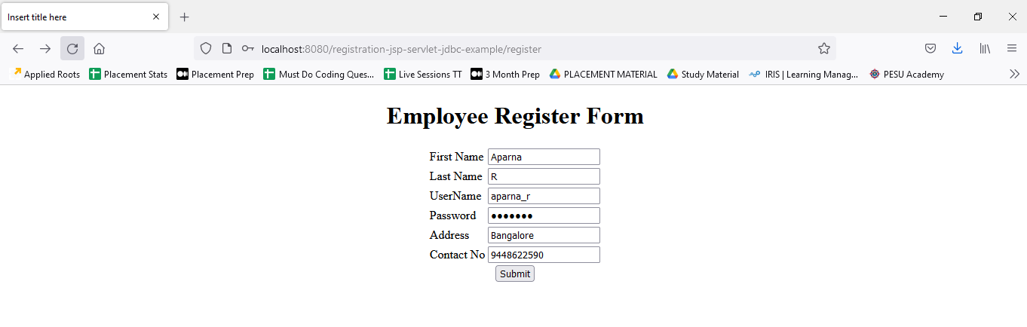

**Shows message after Successful Registration**

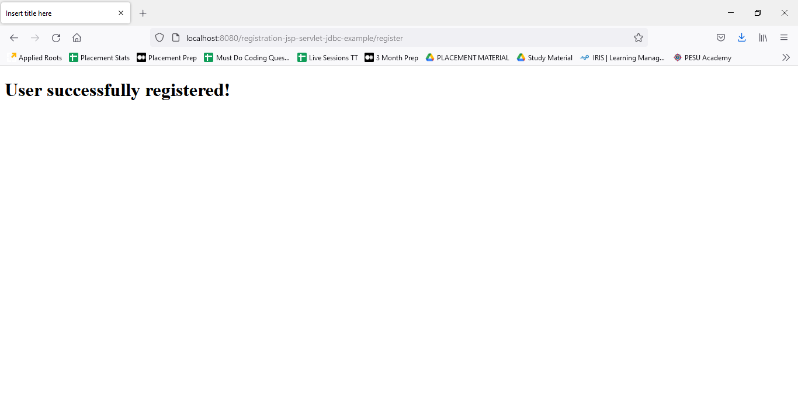

**Data updated in MySQL Database**

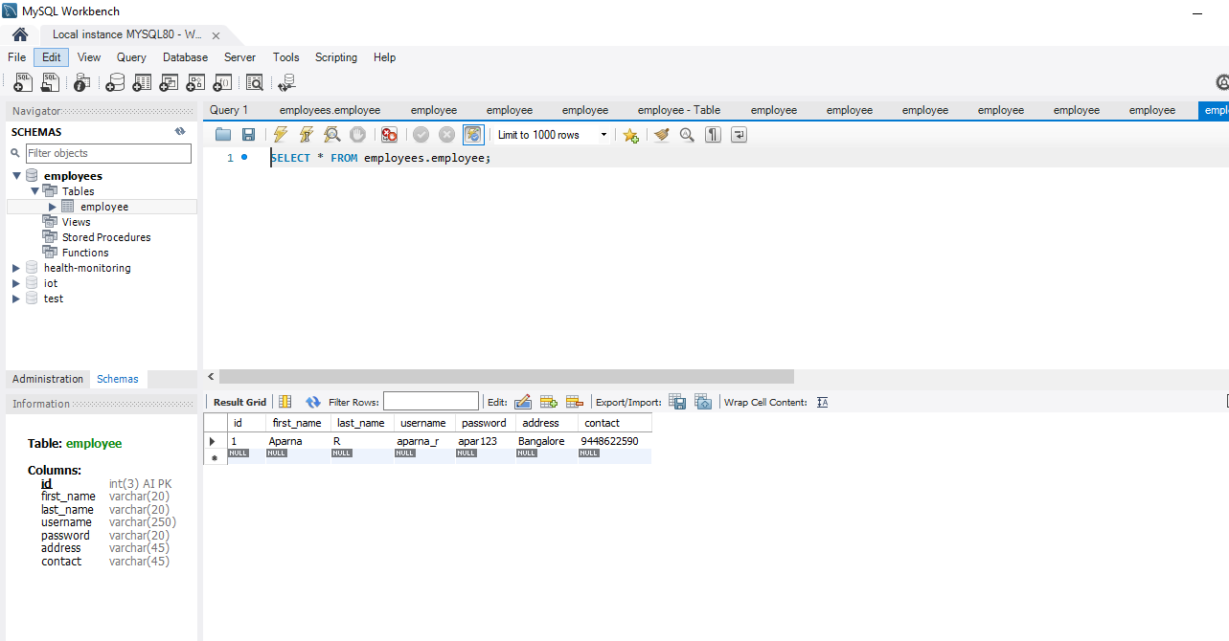

**Linux Assignment**

**Problem Statement -2:**

1. **Search for a pattern (sample) in all the files/subdirectories from current directory.**

**Ans:** grep “word” sample -r

1. **Count the no. of directories / sub directories in current directory.**

**Ans:** ls -d ./* | wc

1. **Display day of week for a given date. (ddmmyyyy).**

**Ans:** date+%A

1. **Display contents of all .lst files in the current directory.**

**Ans:** cat * .lst

1. **For a student file with the following fields, Roll-no, name, marks.**

**Generate 2 files**

**a) 'Pass' and**

**b) Fail**

**containing records of student who have passed or failed. Also count the number of students who have passed or failed.**

**Ans:**

declare -a marks

pass=0

fail=0

marks[$1]=$3

touch Pass.txt

touch Fail.txt

for var in marks

do

if(marks[var]>=35)

then

pass+=1

echo var marks[var] >>Pass.txt

else

fail+=1

echo var arks[var]>>Fail.txt

fi

echo ”passed students $pass”

echo “failed students $fail”

**6. Accept a date string from terminal and display the employees born after the input date.**

**Ans:** ACCEPT input VARCHAR(50) PRINT ”01/01/2000”

SELECT * FROM TABLE WHERE CAST(input as date)>Date;

**7. Find the number of employees belonging to a particular department specified by user.**

**Ans:** SELECT COUNT(emp_id) from Employee where dept=”Development”;

**8. Find the count of people in each dept. of the employee file.**

**Ans:** SELECT COUNT(emp_id), dept FROM Employee GROUP BY dept;

**9. Generate a list of S.E. who earn more than the amount specified by the user.**

**Ans:** SELECT * FROM Employee where salary>50000;

**10. View the employee records in order of designations.**

**Ans:** SELECT * FROM Employee ORDER BY designations;

**11. List employee details of all employees who earn more than the average salary of all employees.**

**Ans:** SELECT * FROM Employee WHERE salary>(SELECT AVG(salary) FROM Employee);

**Jenkins and Docker**

**Problem Statement -3:**

1. Add goals to pom.xml and build docker image of the created project.
2. Run maven pipeline and generate the artifacts.

***Code is attached in Folder named Problem Statement-3***

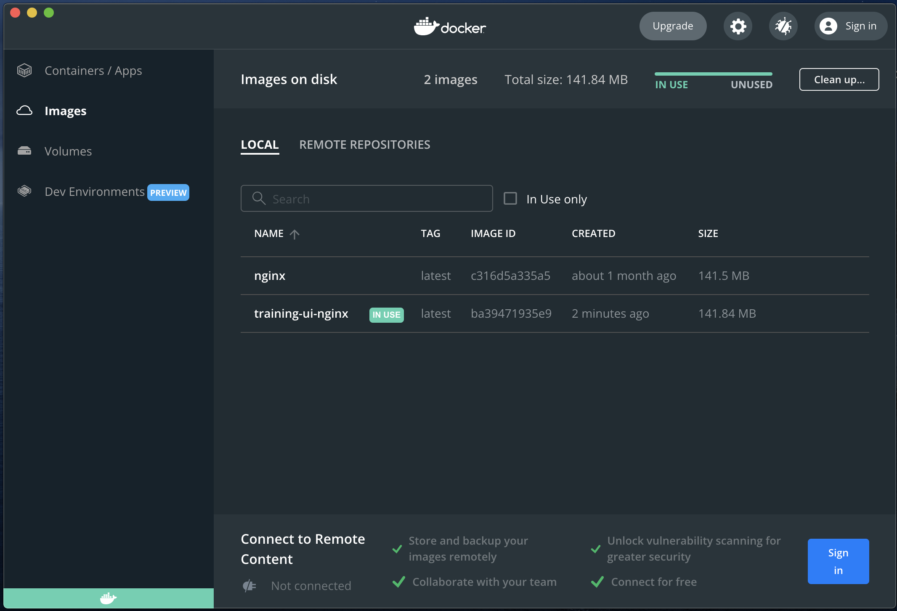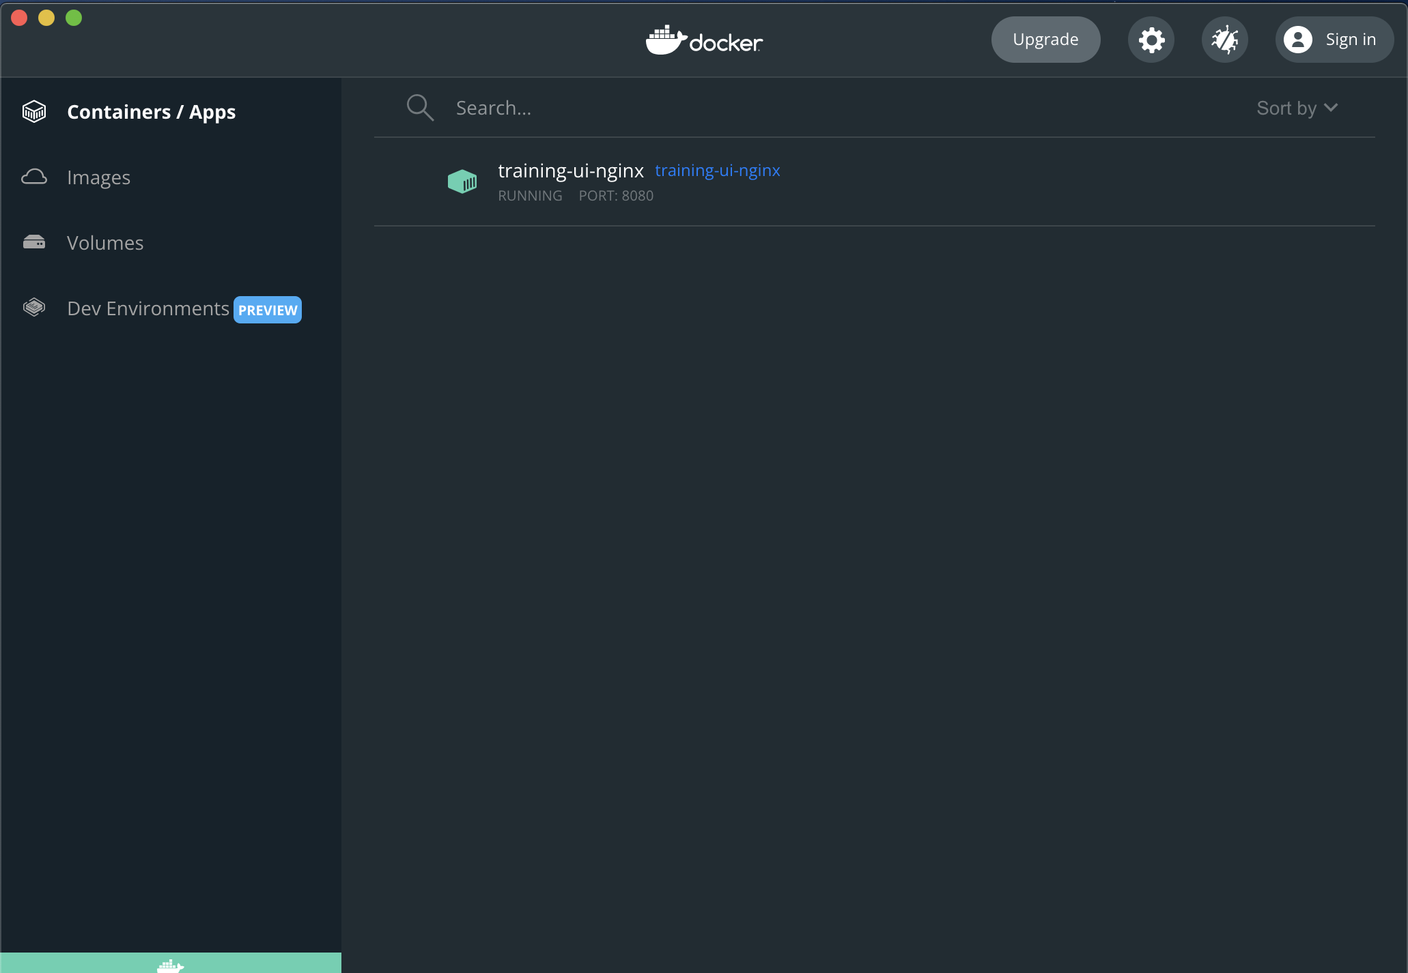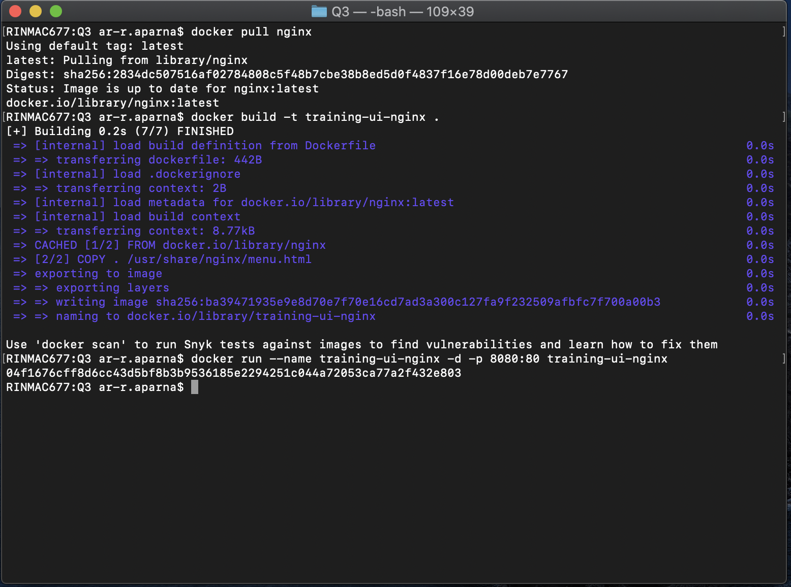

**NodeJS**

**Problem Statement -4:**

1. Build Rest Api with Express for same application design in Java.

***Code is attached in Folder named Problem Statement-4***

**GitHub**

**Problem Statement -5:**

1. Create repository on Github and commit the project code.

***All files are uploaded in my Github repository.***

Link: <https://github.com/Aparna-2000/SummativeAssessment>

<https://github.com/Aparna-2000/Module-Assessment-2>

THANK YOU!!